

**Walmart Sales Data Analysis**

**Calculating some general information :**

How many distinct cities are represented in the dataset where Walmart stores are located?

SELECT COUNT( DISTINCT city) AS 'Number Of Citites'

FROM sales;

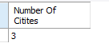

In which city is each Walmart branch located?

SELECT DISTINCT city AS 'City', branch

FROM sales;

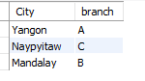

**Calculate some product related information:**

How many product lines the data have ?

SELECT

COUNT(DISTINCT product_line) AS 'Total Product Lines'

FROM

sales;

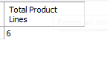

Calculate the most used Payment Method.

SELECT

payment_method, COUNT(payment_method) AS 'Used_in_payments'

FROM

sales

GROUP BY payment_method

ORDER BY Used_in_payments DESC

LIMIT 1;

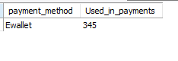

Calculate the most common customer type.

SELECT customer_type, COUNT(customer_type) AS custt_cnt

FROM sales

GROUP BY customer_type

ORDER BY custt_cnt

DESC LIMIT 1;

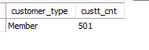

Which customer type buys the most?

SELECT customer_type

FROM (SELECT COUNT(invoice_id), customer_type FROM sales

GROUP BY customer_type ORDER BY COUNT(invoice_id) DESC

LIMIT 1) AS mosyByCustomer;



What is the total revenue by month?

SELECT SUM(total) AS revenue, month_name

FROM sales

GROUP BY month_name

ORDER BY revenue DESC;

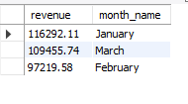

What month had the largest COGS ?

SELECT SUM(cogs) AS total_cogs, month_name

FROM sales

GROUP BY month_name

ORDER BY total_cogs DESC

LIMIT 1;

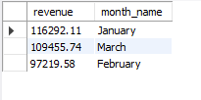

What product line had the largest revenue?

SELECT product_line, SUM(total) AS total_revenue

FROM sales

GROUP BY product_line

ORDER BY total_revenue DESC

LIMIT 1;

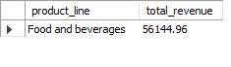

City with largest revenue including specific branch in the city.

SELECT branch,city, SUM(total) AS total_revenue

FROM sales

GROUP BY branch,city

ORDER BY total_revenue DESC LIMIT 1;

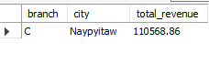

Which product line had the largect VAT ?

SELECT product_line, AVG(VAT) AS total_VAT

FROM sales

GROUP BY product_line

ORDER BY TOTAL_VAT DESC

LIMIT 1;

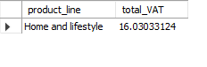

which branch sold more products than the average product sold ?

SELECT branch, SUM(quantity)

FROM sales

GROUP BY branch

HAVING SUM(quantity) > (SELECT AVG(quantity) FROM sales);

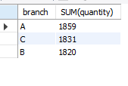

which is the most common product line by gender ?

SELECT gender, product_line, COUNT(gender) AS gen_count

FROM sales

GROUP BY gender, product_line

ORDER BY gen_count DESC;

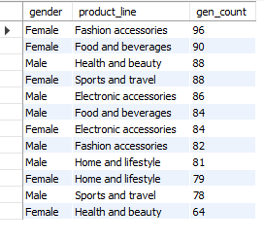

Calculate average rating for each product line

SELECT product_line, ROUND(AVG(rating),2) AS avg_rating

FROM sales

GROUP BY product_line

ORDER BY avg_rating DESC;

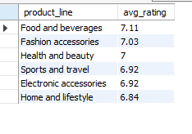

Fetch each product line and add a column to those product

-- line showing "Good", "Bad". Good if its greater than average sales

SELECT AVG(quantity) AS avg_qnty

FROM sales;

SELECT product_line,

CASE

WHEN AVG(quantity) > 6 THEN "Good"

ELSE "Bad"

END AS remark

FROM sales

GROUP BY product_line;

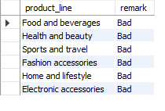

**Calculate some customer related information:**

How many unique customer types does the Data have?

SELECT COUNT(DISTINCT customer_type) AS 'Customer_types'

FROM sales;

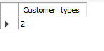

How many unique payment method does the Data have?

Select count(distinct payment_method)

From sales;

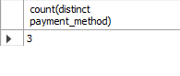

What is the most common customer type?

Select customer_type, count(customer_type) as customers

from sales

group by customer_type

order by customers desc limit 1;

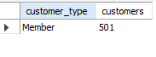

What is the gender of most of the customers?

SELECTbgender, COUNT(*) AS 'no_of_orders'

FROM sales

GROUP BY gender

ORDER BY count(*) DESC LIMIT 2;

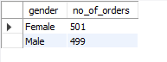

What is the gender distribution per branch?

SELECT branch, gender,COUNT(gender) AS 'No_of_customers'

FROM sales

GROUP BY branch,gender

order by branch ;

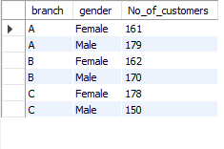

Which time of the day do the customers gives most ratings?

Select time_of_day, count(rating) as rating_cnt

From sales

group by time_of_day

order by rating_cnt desc limit 1;



Which time of the day do the customers gives most ratings per branch?

Select time_of_day, branch, count(rating) as rating_cnt

From sales

group by time_of_day,branch

order by branch;

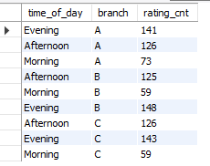

Which day of the week has the best average ratings?

Select day_name,avg(rating) as avg_rating

From sales

group by day_name

order by avg_rating desc limit 1;



**Calculate some sales related information:**

The number of sales made in each time of day per weekday?

SELECT day_name,time_of_day,COUNT(*) AS 'Orders'

FROM sales

GROUP BY time_of_day,day_name

ORDER BY day_name;

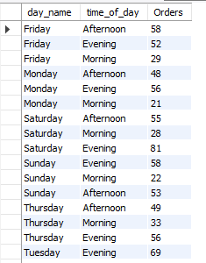

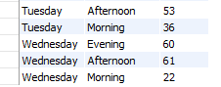

Which of the customer types bring the most revenue?

SELECT customer_type, SUM(total) AS revenue

FROM sales

GROUP BY customer_type

ORDER BY revenue DESC LIMIT 1;



Which city has the largest tax percent / VAT(value add tax)?

SELECT city, AVG(VAT) AS vat

FROM sales

GROUP BY city

ORDER BY vat DESC LIMIT 1;



Which customer type pays the most in vat?

SELECT customer_type, AVG(VAT) AS vat

FROM sales

GROUP BY customer_type

ORDER BY vat DESC LIMIT 1;



**Creating Table in MySQL Workbench in which we insert our csv file.**

CREATE TABLE IF NOT EXISTS SALES(

invoice_id varchar(30) not null primary key,

branch varchar(10) NOT NULL,

city varchar(30) NOT NULL,

customer_type varchar(30) NOT NULL,

gender varchar(10) not null,

product_line VARCHAR(100) NOT NULL,

unit_price DECIMAL(10,2) NOT NULL,

quantity INT NOT NULL,

VAT float(6,4) NOT NULL,

total DECIMAL(10,2),

Date datetime not null ,

time time not null,

payment_method varchar(15) not null,

cogs decimal(10,2) not null,

cogs_margin_pct float(11,9) not null,

gross_income decimal(12,4) not null,

rating float(4,2) not null

);

**Data Cleaning And Transformations:**

-- -----------------------------FEATURE ENGINEERING -------------------------------------------- time_of_day

select

time,

(case when `time` between "00:00:00" and "12:00:00" then "Morning"

when `time` between "12:01:00" and "16:00:00" then "Afternoon"

else "Evening"

end ) as time_of_day

from sales;

**Create Table which show’s the time of the day**

alter table sales add column time_of_day varchar(30);

SET SQL_SAFE_UPDATES = 0;

update sales

set time_of_day = (

case

when `time` between "00:00:00" and "12:00:00" then "Morning"

when `time` between "12:01:00" and "16:00:00" then "Afternoon"

else "Evening"

end

);

-- ------------DAY_NAME--------------------------

select date, dayname(date) as day_name

from sales;

alter table sales add column day_name varchar(10);

update sales

set day_name = dayname(date);

-- ------------MONTH_NAME--------------------------

select date, monthname(date) as month_name

from sales;

ALTER table sales add column month_name varchar(10);

update sales

set month_name = monthname(date);